**MODEL META DATA**

**Model Name:** u-net-1000images-baseline

**Architecture:** U-Net

**Numpy or Image Generator:** Numpy

**Epochs:** 10

**Batch size:** 8

**Learning rate:** 0.01

**No of images:** 1008

**Performance Metrics:** IOU, Accuracy

**Colab or Kaggle:** Colab

**Filename:** Basic U-Net

**Results:** IOU - 18.06, Accuracy - 95.81

**Comments:** Scaling done by directly dividing by 255

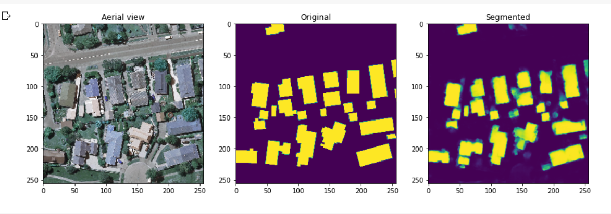

**Model Name:** unet-youtube-1000images-10epochs

**Architecture:** U-Net

**Numpy or Image Generator:** Numpy

**Epochs:** 10

**Batch size:** 16

**Learning rate:** 0.01

**No of images:** 1008

**Performance Metrics:** IOU, Dice Coefficient, Accuracy

**Colab or Kaggle:** Colab

**Filename:** Youtube U-Net

**Results:** IOU - 64.73, Dice Coefficient - 78.43 Accuracy - 94.84

**Comments:** Used MinMaxScaler, Referred Digital Sreeni video

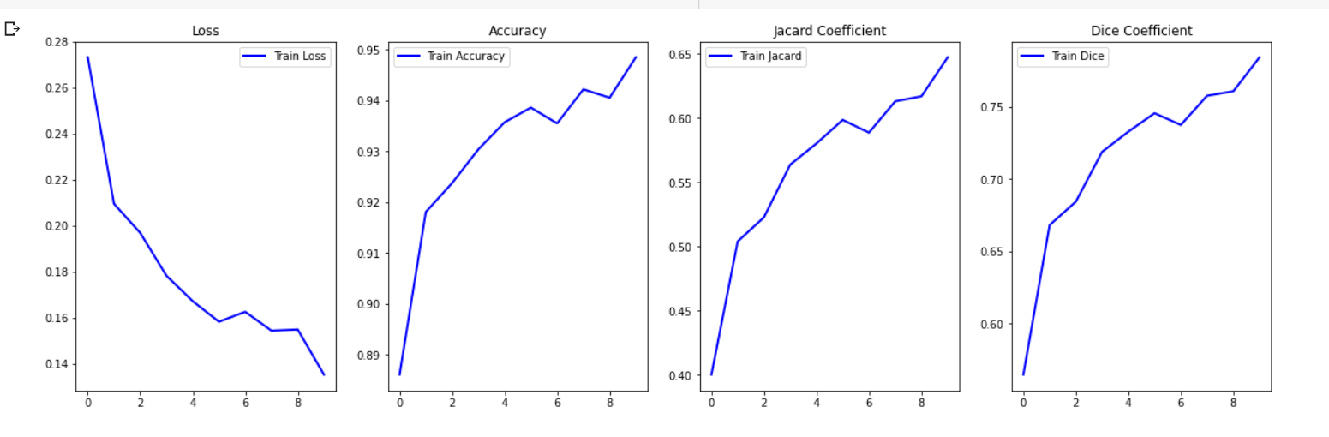

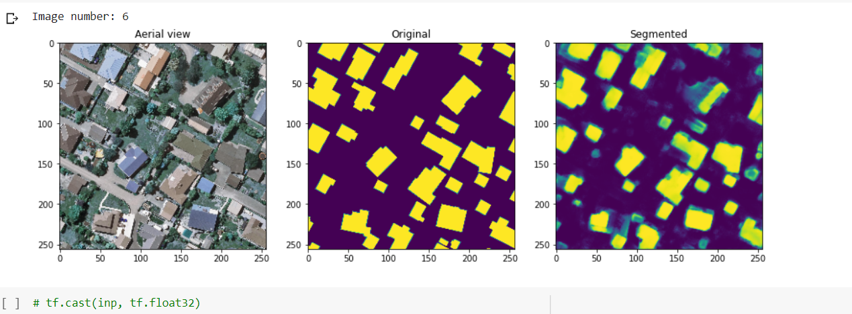

**Model Name:** unetmcc-youtube-1000images-10epochs

**Architecture:** U-Net

**Numpy or Image Generator:** Numpy

**Epochs:** 10

**Batch size:** 16

**Learning rate:** 0.01

**No of images:** 1008

**Performance Metrics:** IOU, Dice Coefficient, MCC, Accuracy

**Colab or Kaggle:** Colab

**Filename:** Youtube U-Net

**Results:** IOU - 68.22, Dice Coefficient - 80.99, MCC - 14.40, Accuracy - 95.37

**Comments:** Used MinMaxScaler, Added MCC also as performance metrics, Referred Digital Sreeni video

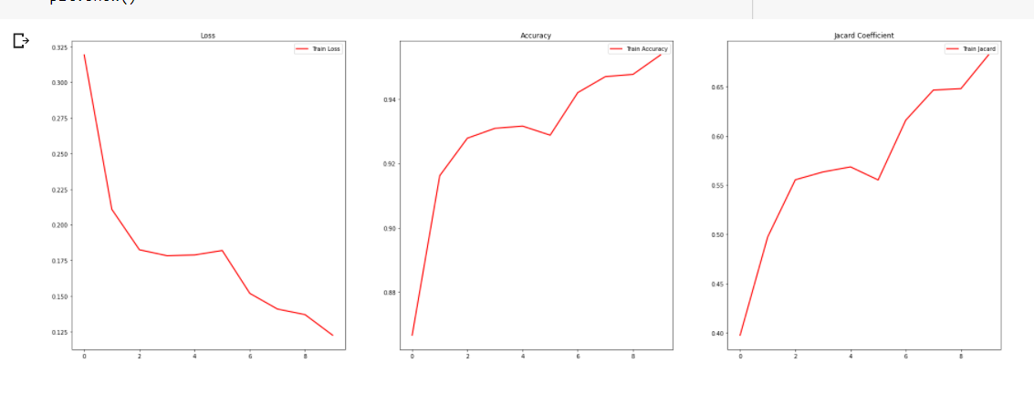

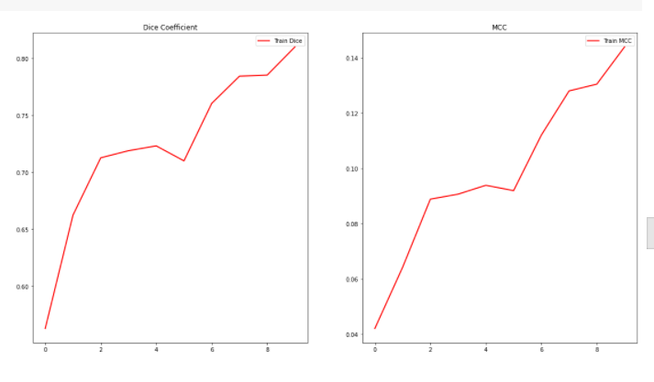

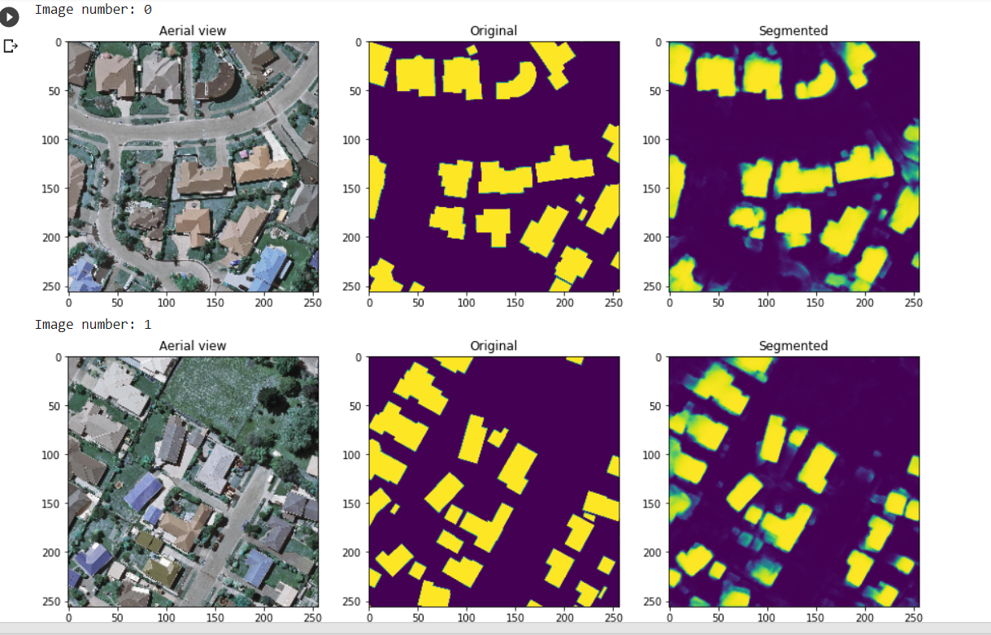

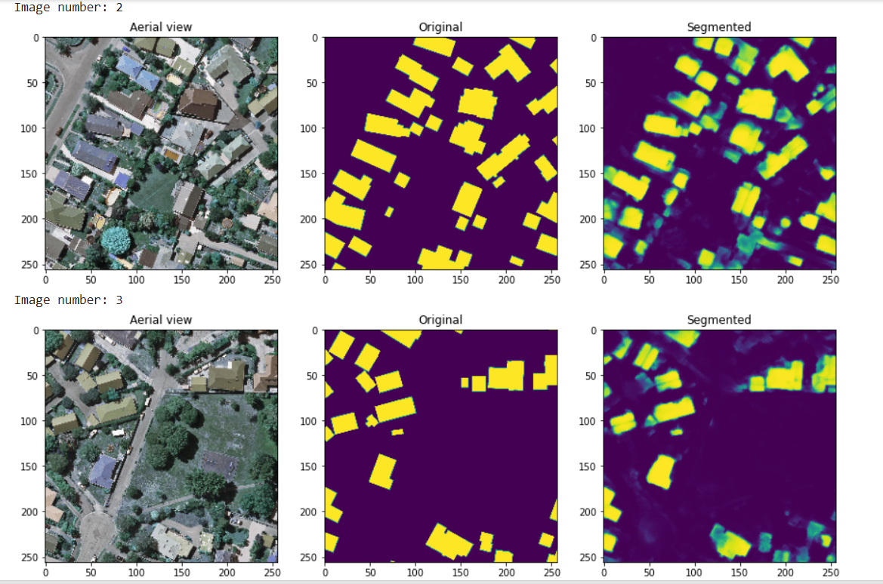

**Model Name:** resumable-model

**Architecture:** U-Net

**Numpy or Image Generator:** Numpy

**Epochs:** 15

**Batch size:** 8

**Learning rate:** 0.001

**No of images:** 1008

**Performance Metrics:** IOU, Dice Coefficient, MCC, Accuracy

**Colab or Kaggle:** Colab

**Filename:** Youtube U-Net

**Results:** IOU - 70.36, Dice Coefficient - 82.34, MCC - NaN, Accuracy - 94.98

**Comments:** Same as above, Tried How to start, stop resume training of a model using keras-buoy

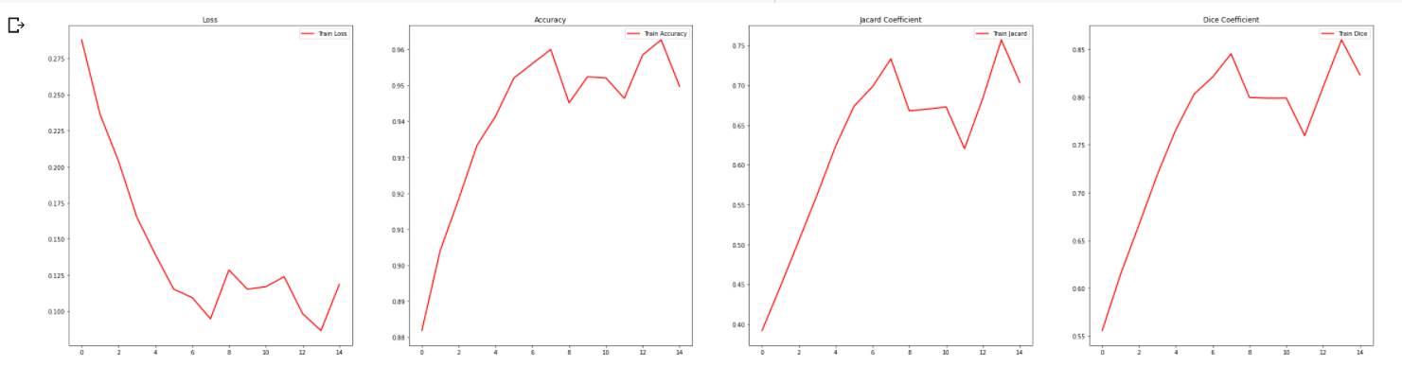

**Model Name:** 1500images-30epochs

**Architecture:** MultiRes U-Net

**Numpy or Image Generator:** Numpy

**Epochs:** 30

**Batch size:** 8

**Learning rate:** 0.0001

**No of images:** 1548

**Performance Metrics:** IOU, Dice Coefficient, MCC, Accuracy

**Colab or Kaggle:** Kaggle

**Filename:** 1500 Numpy MultiRes Version 1 - Numpy MultiRes, U-Net

**Results:** IOU - 30.21, Dice Coefficient - 45.87, MCC - 0.89, Accuracy - 97.53, Loss - 0.3288

**Comments:** Tried MultiRes U-Net with numpy array.

**Model Name:** 1500images-npy-100epochs

**Architecture:** U-Net

**Numpy or Image Generator:** Numpy

**Epochs:** 100

**Batch size:** 8

**Learning rate:** 0.0001

**No of images:** 1548

**Performance Metrics:** IOU, Dice Coefficient, MCC, Accuracy

**Colab or Kaggle:** Kaggle

**Filename:** 1500 Numpy MultiRes Version 1 - Numpy MultiRes, U-Net

**Results:** IOU - 86.81, Dice Coefficient - 92.83, MCC - 48.97, Accuracy - 98.28, Loss - 0.0339

**Comments:** U-Net with numpy array. Ran faster than in Colab. Took 48s for each epoch in Kaggle compared to 2mins in Colab.

**Model Name:** focalloss-30epochs

**Architecture:** MultiRes U-Net

**Numpy or Image Generator:** Numpy

**Epochs:** 100

**Batch size:** 8

**Learning rate:** 0.0001

**No of images:** 1008

**Performance Metrics:** IOU, Dice Coefficient, MCC, Accuracy

**Colab or Kaggle:** Kaggle

**Filename:** Keras Data Generator Version 1 - multires-30

**Results:** IOU - 32.33, Dice Coefficient - 48.43, MCC - 0.88, Accuracy - 97.73, Loss - 0.0422

**Comments:** MultiRes with binary focal loss instead of binary cross entropy loss.

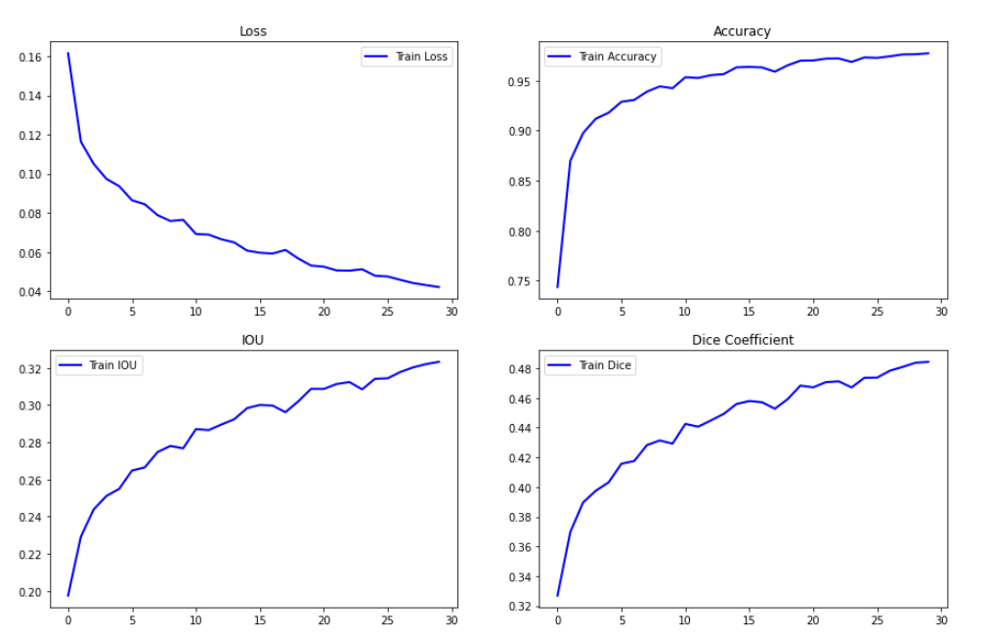

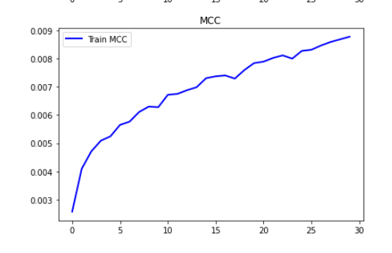

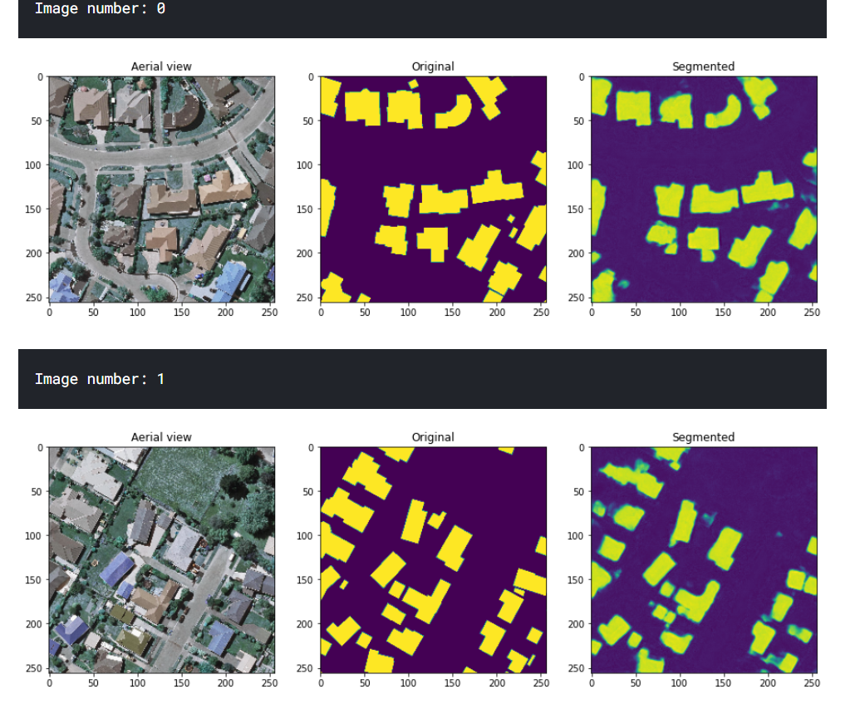

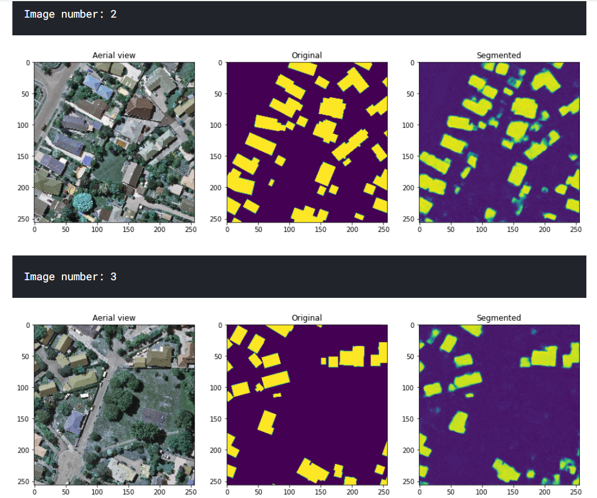

**Model Name:** MultiRes-100epochs-lr1e-4

**Architecture:** MultiRes U-Net

**Numpy or Image Generator:** Numpy

**Epochs:** 100

**Batch size:** 16

**Learning rate:** 0.0001

**No of images:** 1008

**Performance Metrics:** IOU, Dice Coefficient, MCC, Accuracy

**Colab or Kaggle:** Kaggle

**Filename:** Keras Data Generator Version 1 - multires-30

**Results:** IOU - 35.18, Dice Coefficient - 51.91, MCC - 1.66, Accuracy - 97.51, Loss - 0.3047

**Comments:** IOU with MultiRes doesn't increase after 35% even with 100 epochs for different learning rates as well. For learning rate = 0.01, IOU at end of 100 epochs is 38.93%.

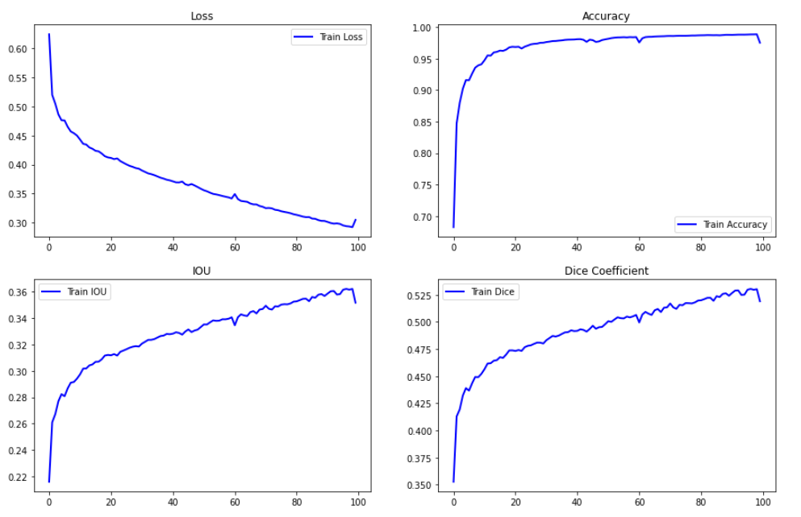

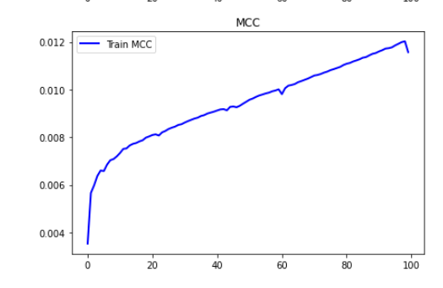

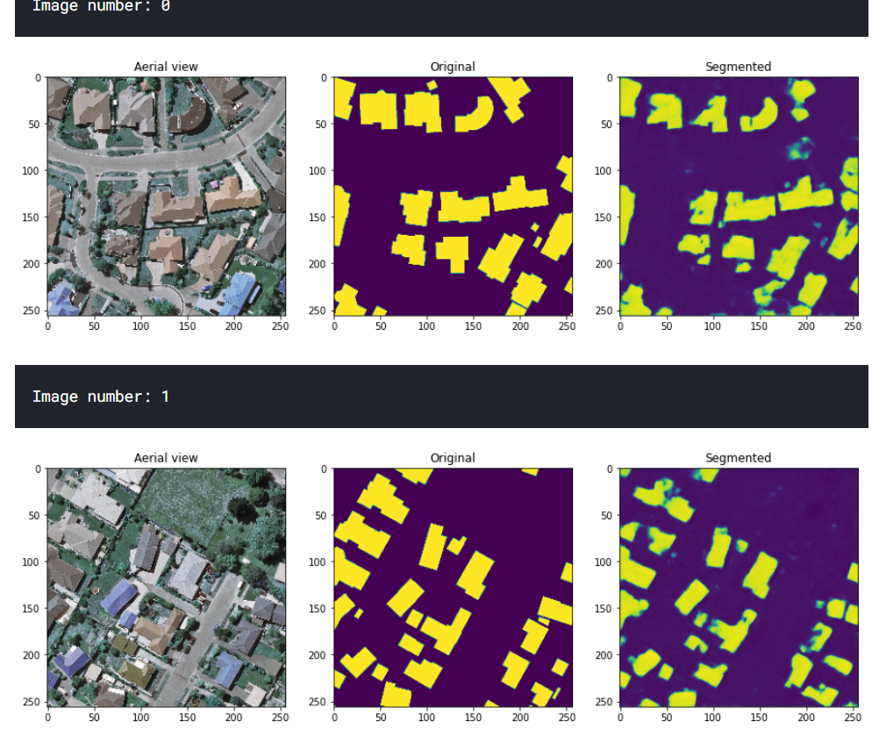

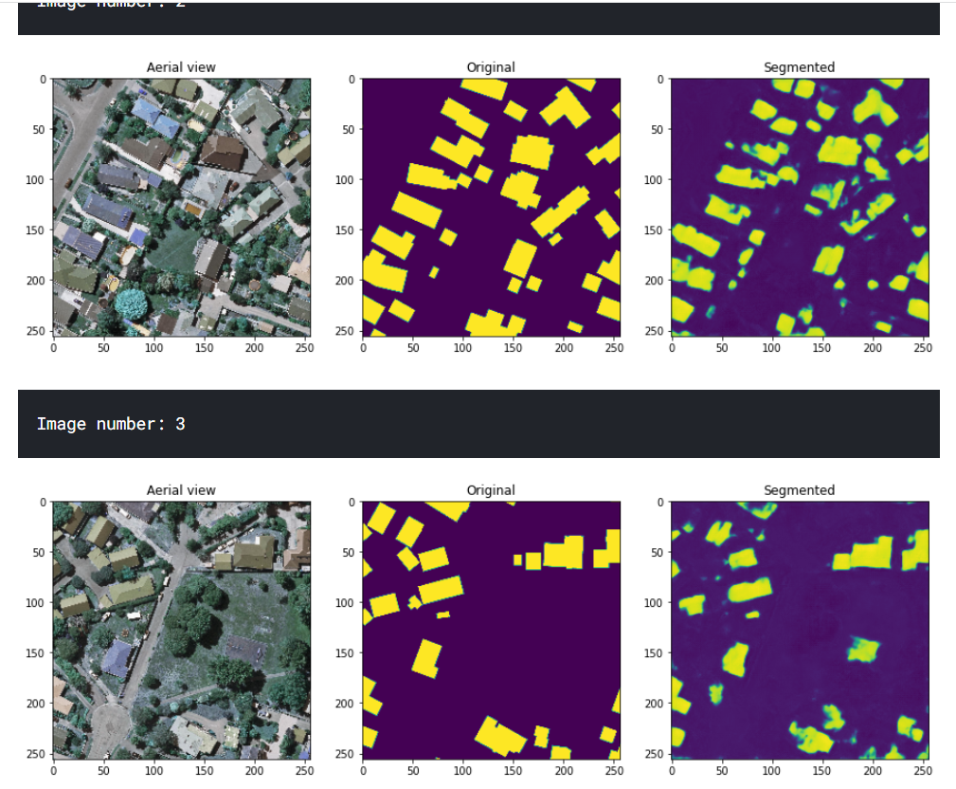

**Model Name:** unet2-1000images-100epochs

**Architecture:** U-Net

**Numpy or Image Generator:** Numpy

**Epochs:** 100

**Batch size:** 8

**Learning rate:** 0.0001

**No of images:** 1008

**Performance Metrics:** IOU, Dice Coefficient, MCC, Accuracy

**Colab or Kaggle:** Colab

**Filename:** U-Net Final

**Results:** IOU - 88.40, Dice Coefficient - 93.79, MCC – 51.68, Accuracy – 98.22, Loss – 0.0356

**Comments:** Tried resumable models too but that wasn't done properly.

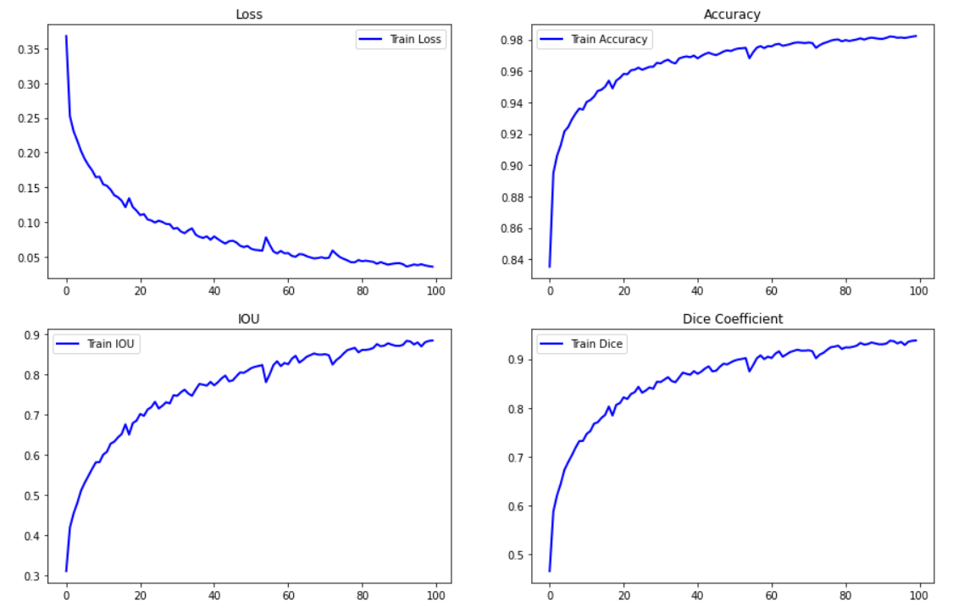

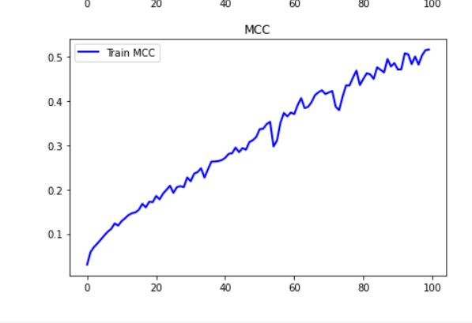

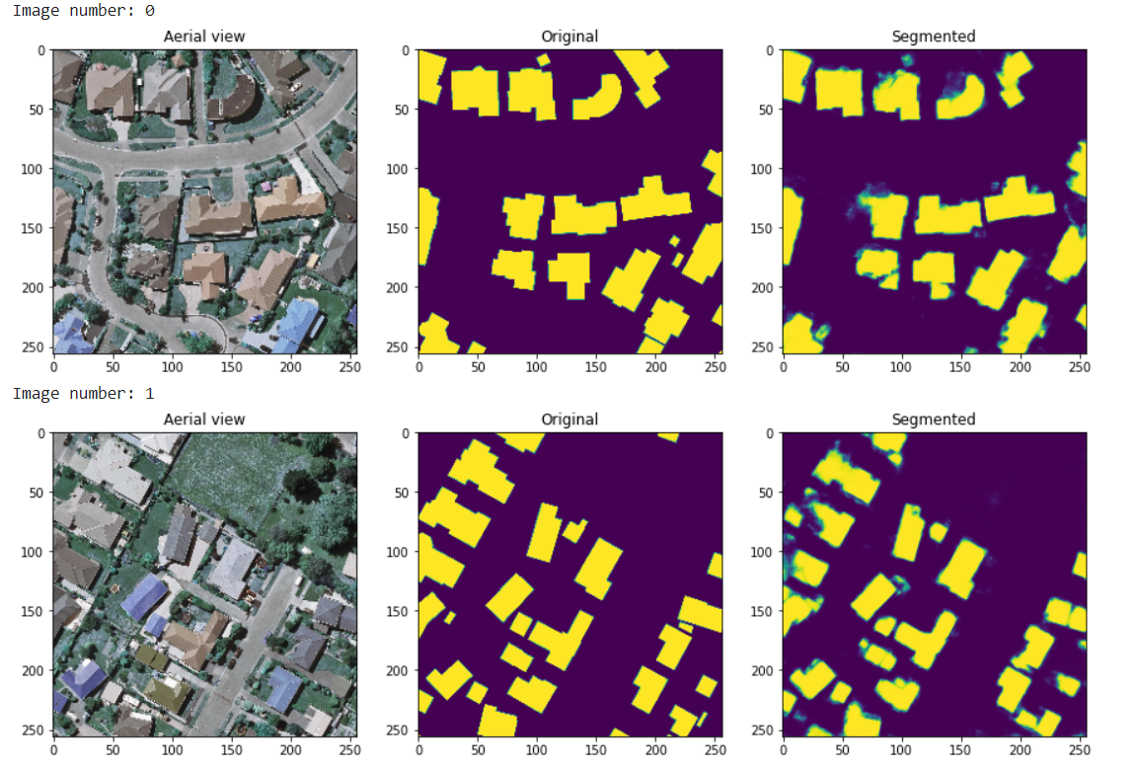

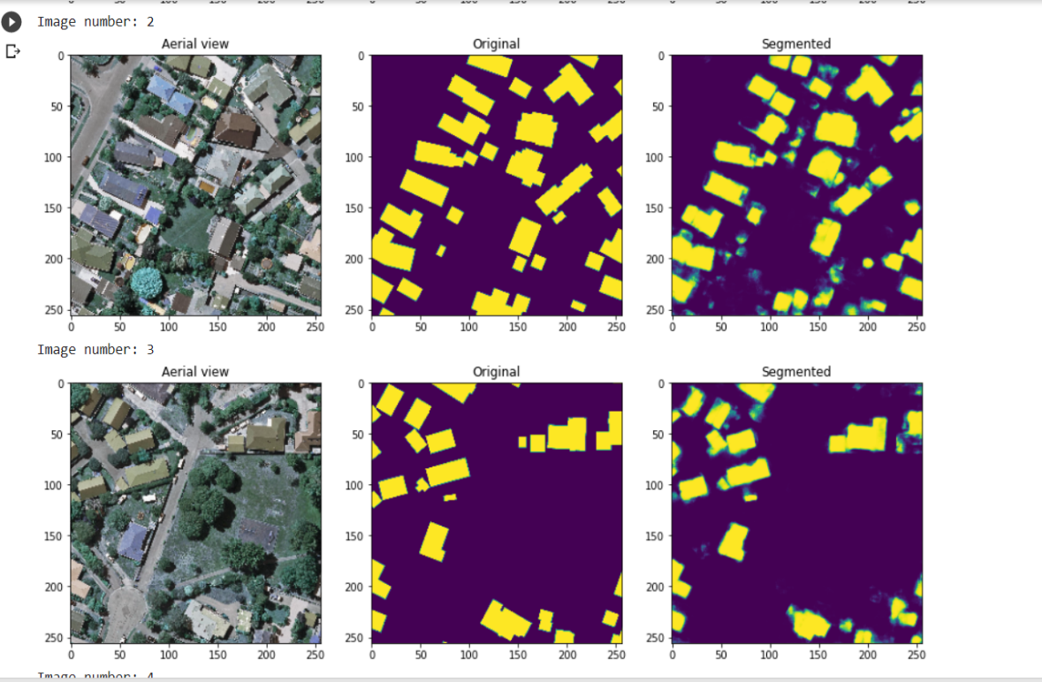

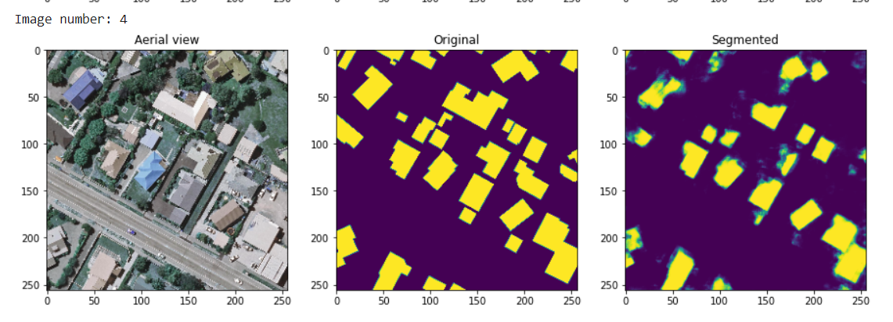

**Model Name:** unet2-1000images-130epochs

**Architecture:** U-Net

**Numpy or Image Generator:** Numpy

**Epochs:** 30 (Continue training from the previous model) 100+30=130

**Batch size:** 8

**Learning rate:** 0.00001

**No of images:** 1008

**Performance Metrics:** IOU, Dice Coefficient, MCC, Accuracy

**Colab or Kaggle:** Colab

**Filename:** U-Net Final

**Results:** IOU - 90.57, Dice Coefficient - 95.02, MCC - 56.88, Accuracy - 98.48, Loss - 0.0279

**Comments:** Continued training from the previous model by loading the weights and decreasing the learning rate. Trained for 30 more epochs.

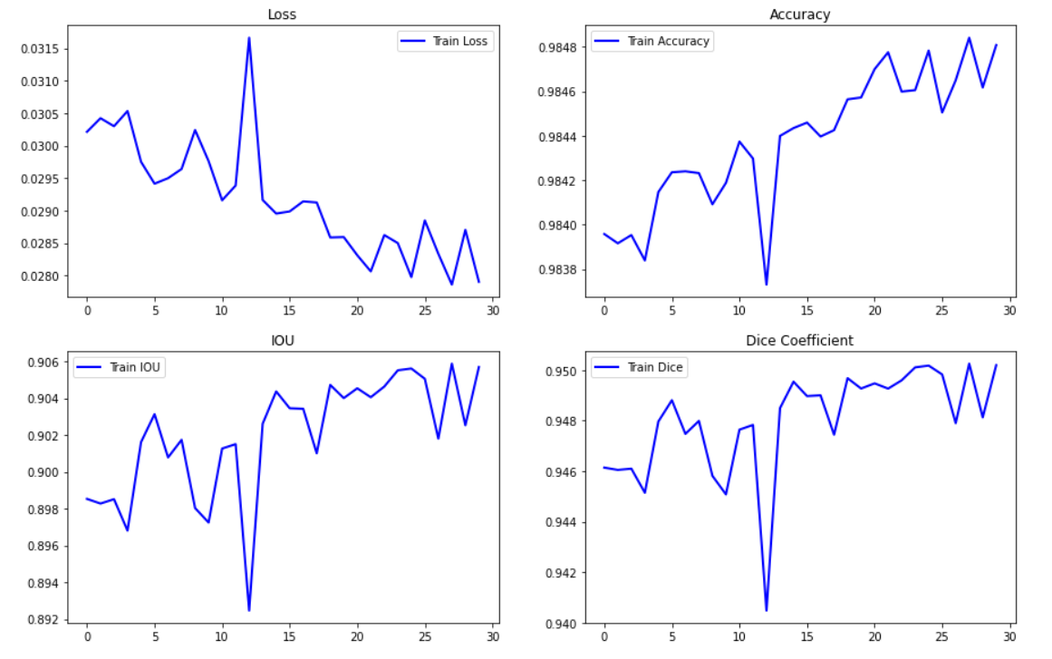

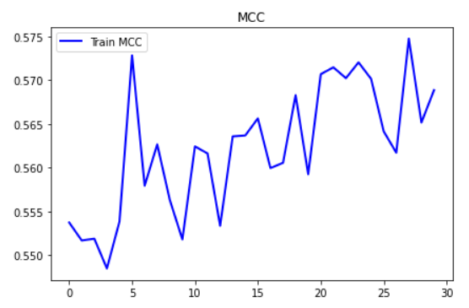

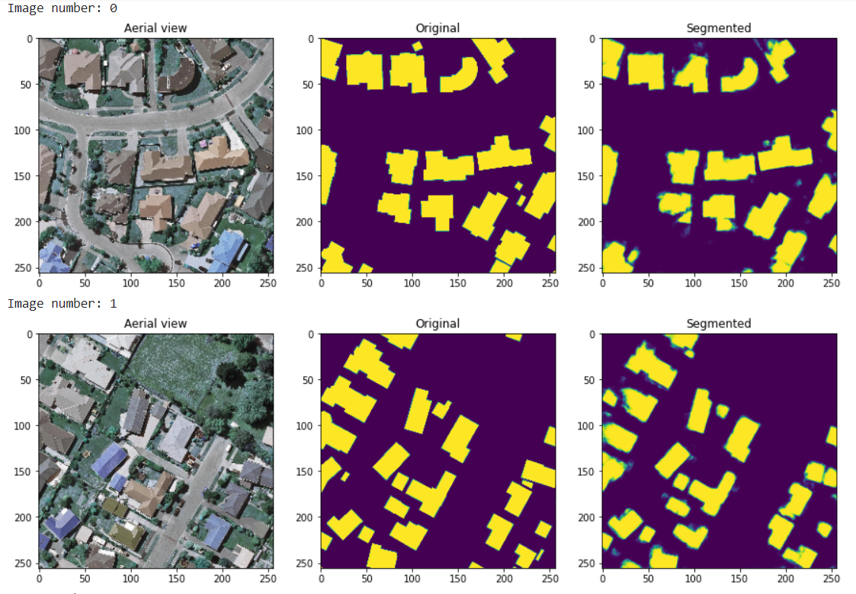

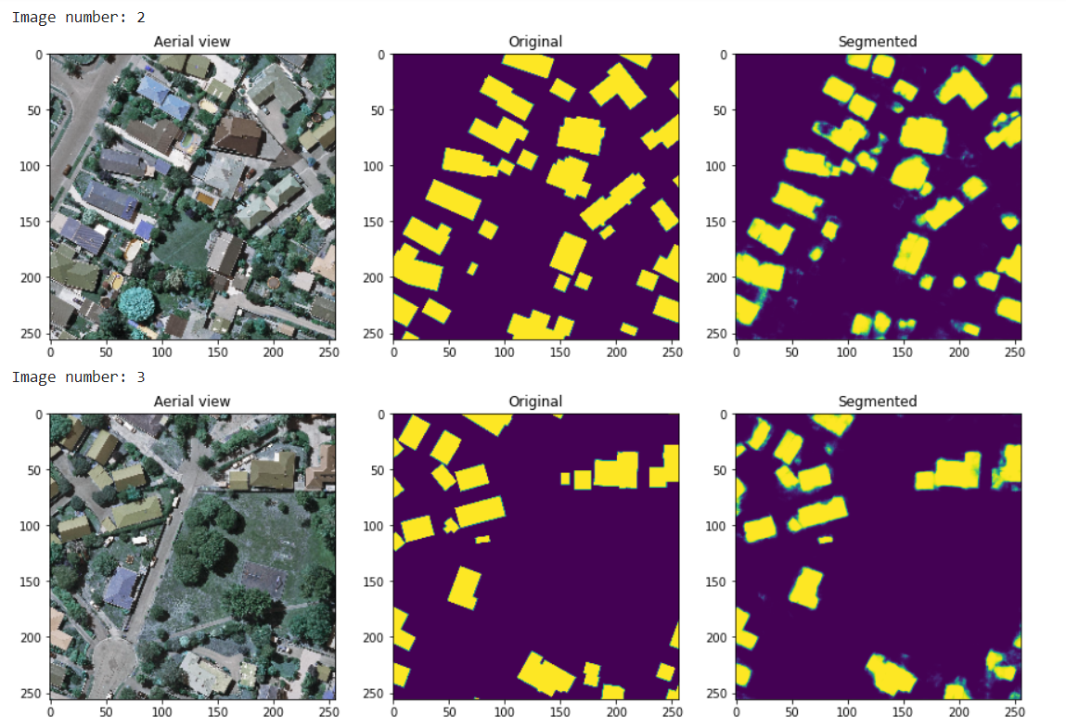

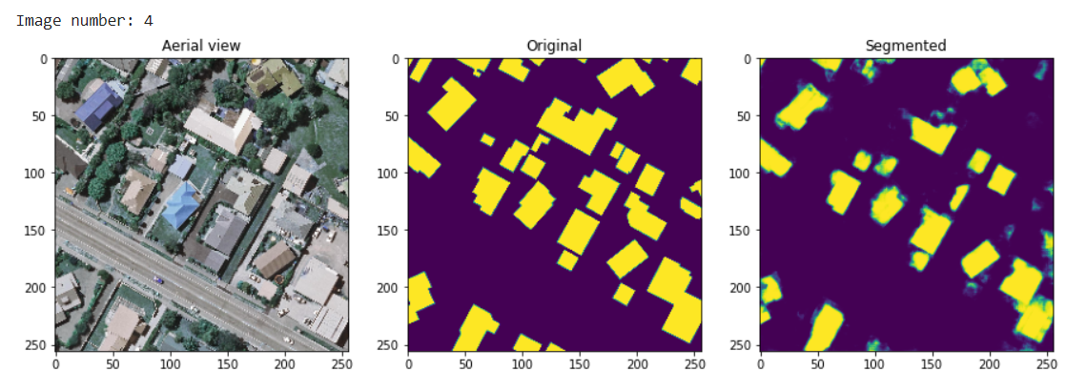

**Model Name:** multires-100epochs

**Architecture:** MultiRes U-Net

**Numpy or Image Generator:** Numpy

**Epochs:** 100 (256*192) (50 + 50 epochs)

**Batch size:** 8

**Learning rate:** 0.01

**No of images:** 500

**Performance Metrics:** IOU, Dice Coefficient, MCC, Accuracy

**Colab or Kaggle:** Colab

**Filename:** MultiRes UNet v1

**Results:** IOU - 39.42, Dice Coefficient - 56.53, MCC - 2.77, Accuracy - 94.44, Loss - 0.2037

**Comments:** MultiRes UNet (original filter) not as in base paper. The output segmentation masks results seem somewhat good and performance has improved slightly.

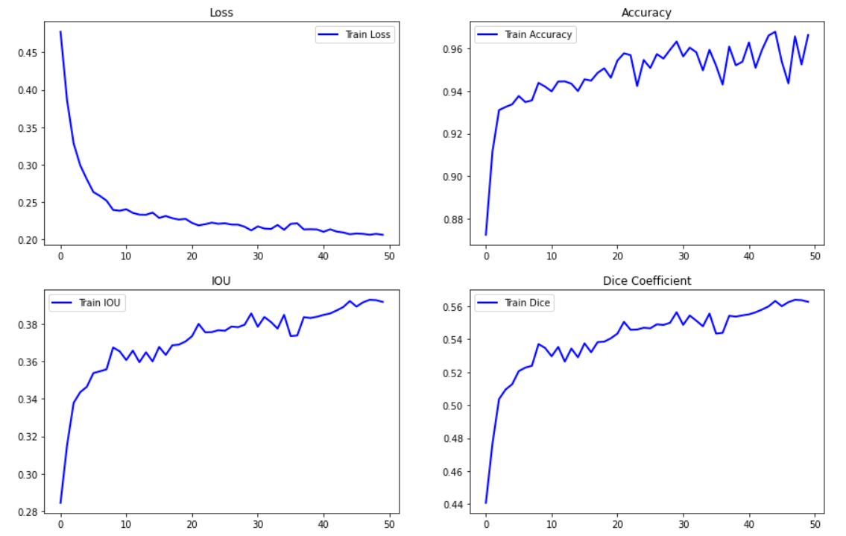

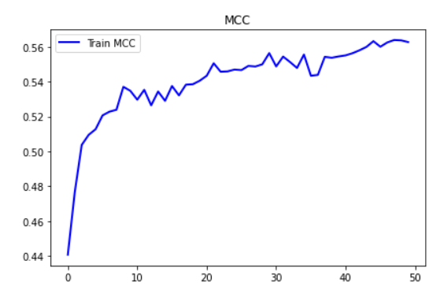

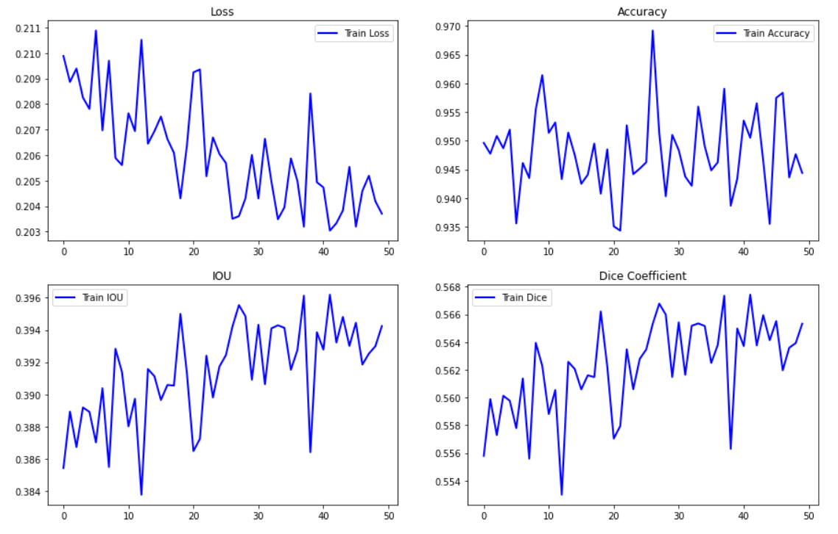

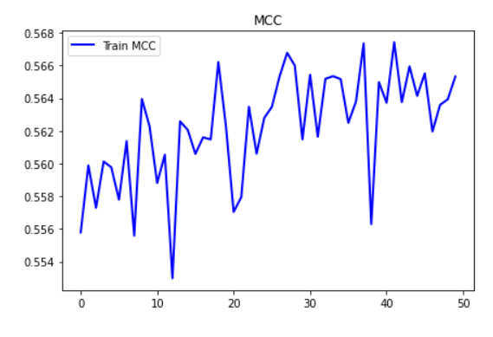

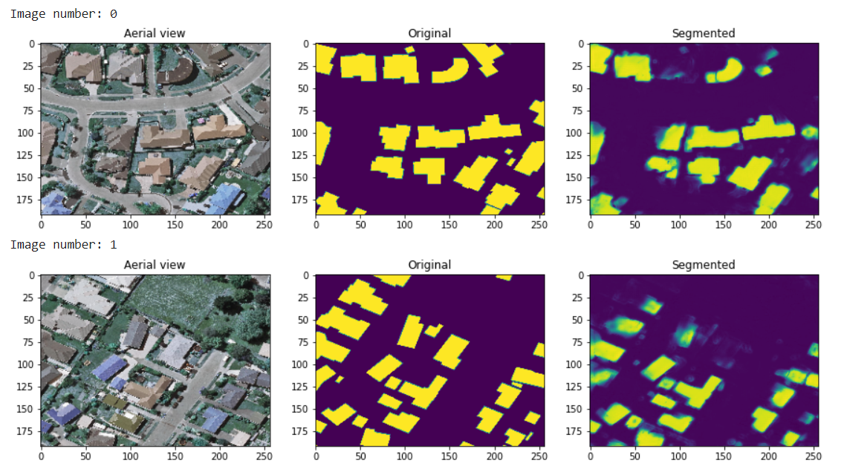

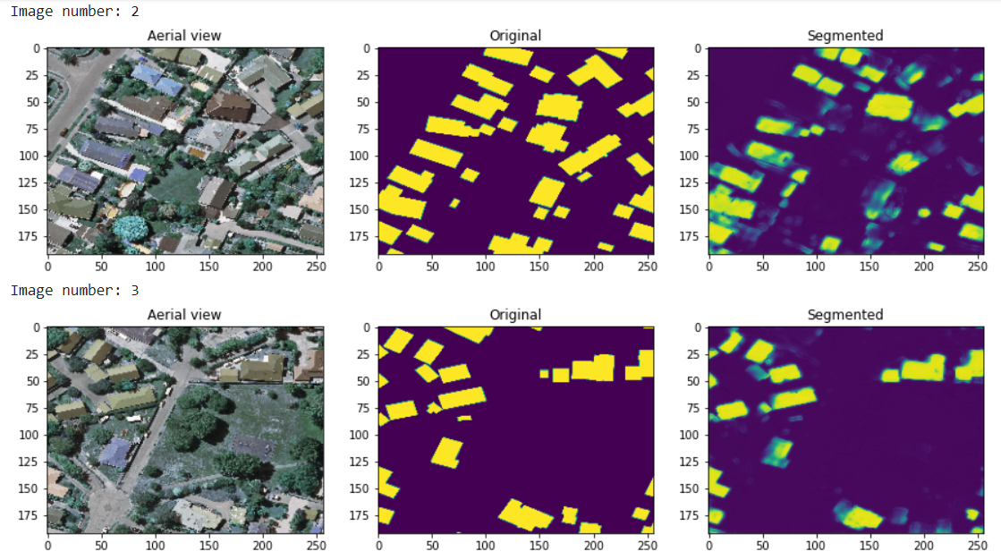

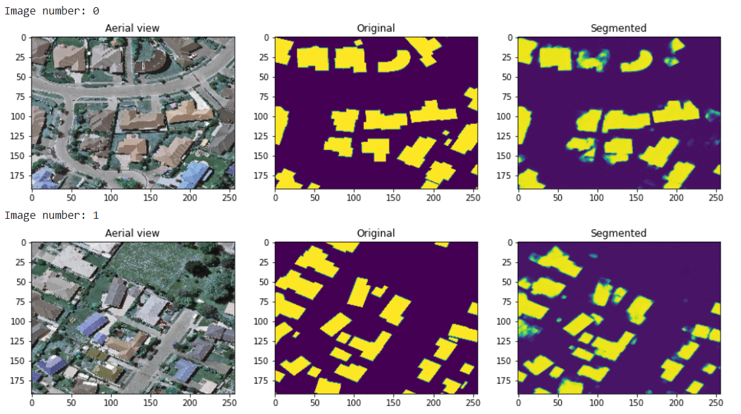

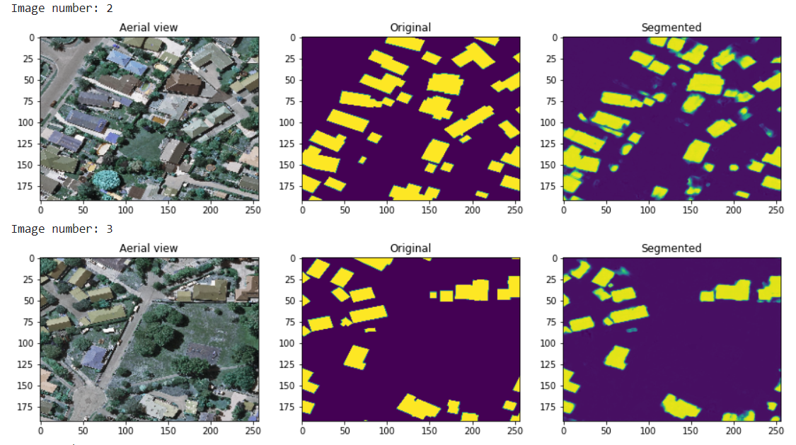

**Model Name:** Dropout-500images-30epochs-MultiRes

**Architecture:** MultiRes U-Net

**Numpy or Image Generator:** Numpy

**Epochs:** 30 (256*192)

**Batch size:** 8

**Learning rate:** 0.01

**No of images:** 500

**Performance Metrics:** IOU, Dice Coefficient, MCC, Accuracy

**Colab or Kaggle:** Kaggle

**Filename:** 1500 Numpy MultiRes Version 3 - Dropout-MultiRes-500

**Results:** IOU - 30.58, Dice Coefficient - 46.39, MCC - 2.07, Accuracy - 90.41, Loss - 0.3374

**Comments:** Used Dropout (0.3) in conv_2d_bn function. 56 dropouts.

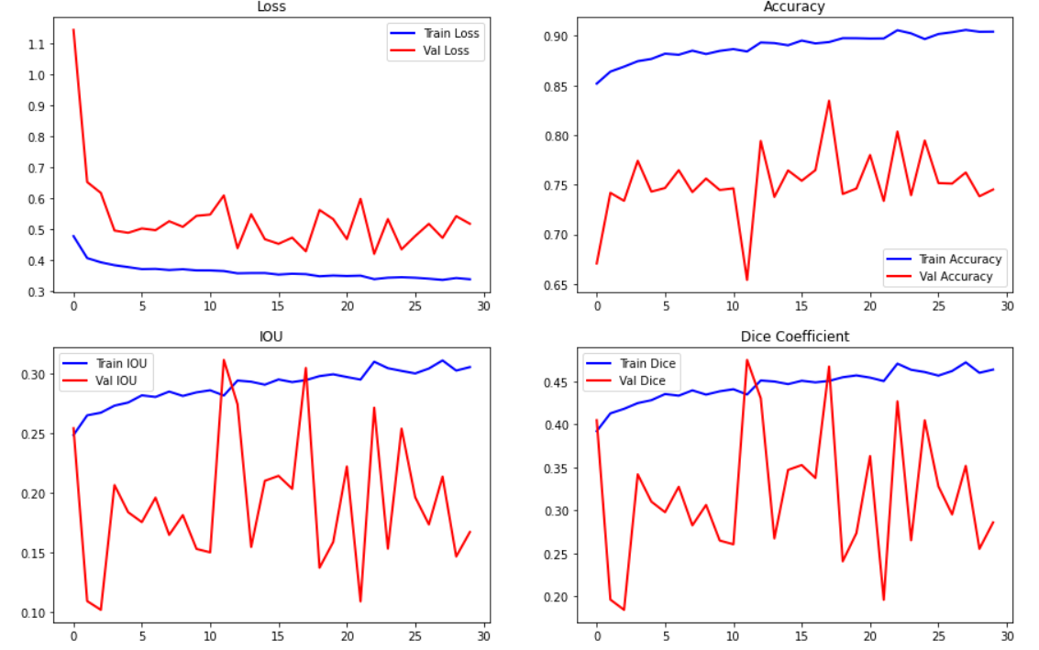

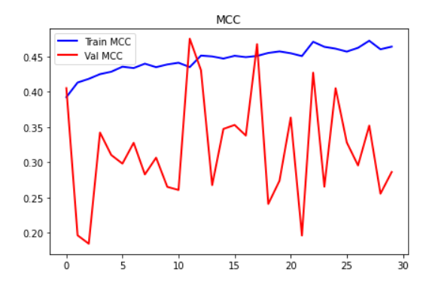

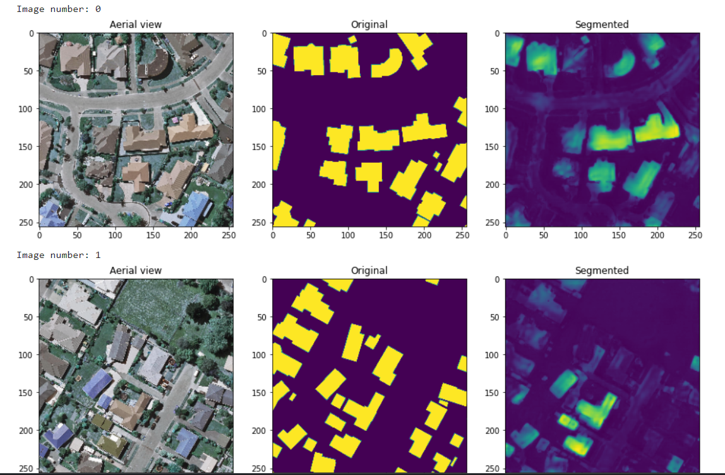

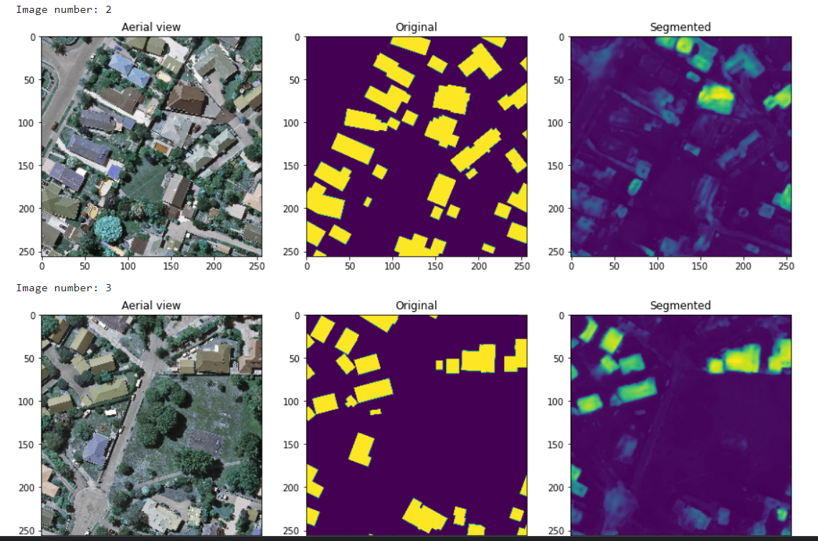

**Model Name:** multires-pro-500images-bp-50epochs

**Architecture:** MultiRes U-Net

**Numpy or Image Generator:** Numpy

**Epochs:** 50 (256*256)

**Batch size:** 8

**Learning rate:** 0.001

**No of images:** 500

**Performance Metrics:** IOU, Dice Coefficient, MCC, Accuracy

**Colab or Kaggle:** Colab Pro

**Filename:** Pro - MultiRes UNet

**Results:** IOU - 39.17, Dice Coefficient - 56.27, MCC - 2.79, Accuracy - 95.21, Loss - 0.3917

**Comments:** Tried in Colab Pro with filters as mentioned in base paper & image dimensions (256*256).

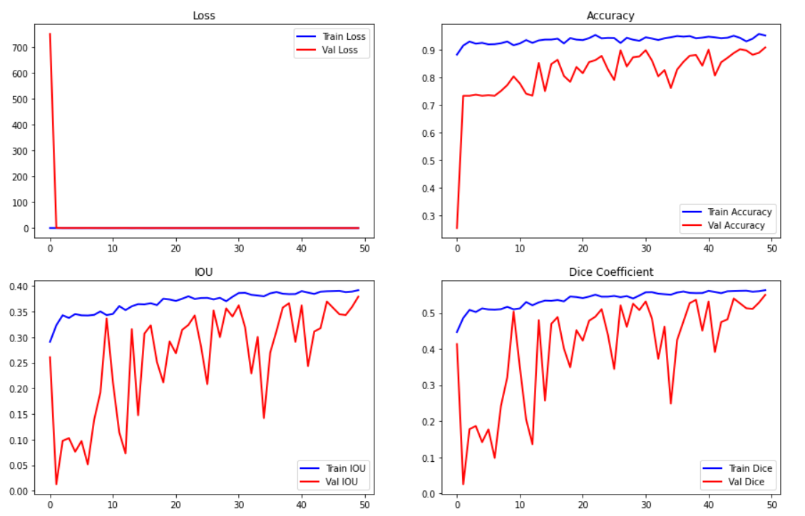

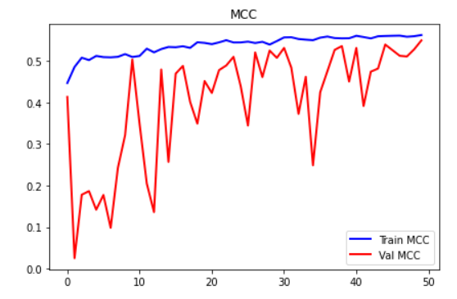

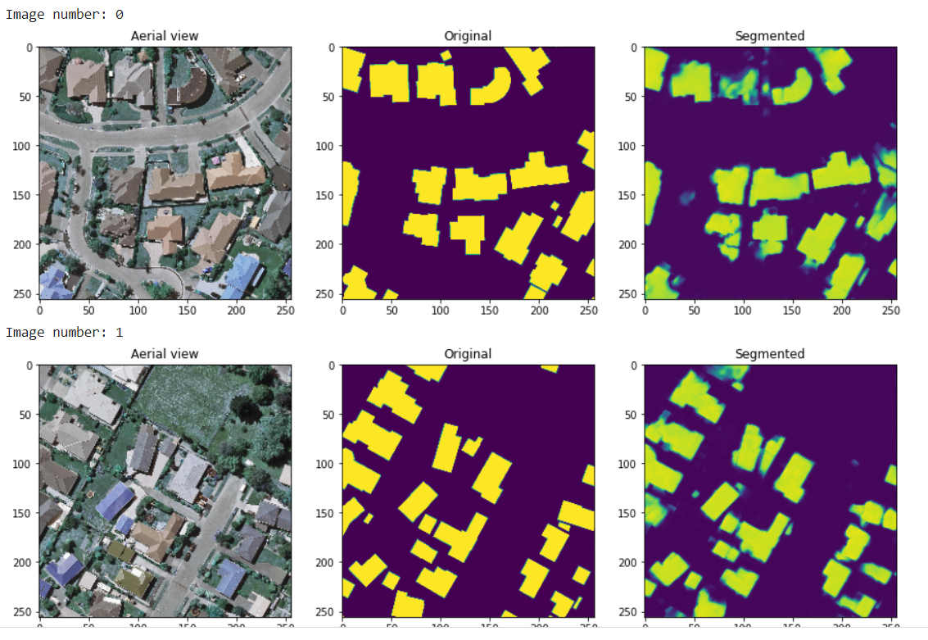

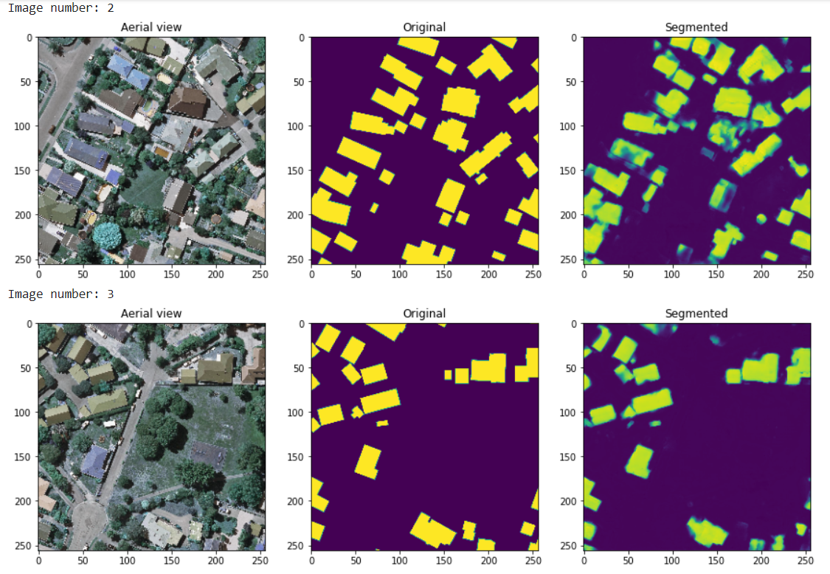

**Model Name:** multires-pro-allimages-40epochs

**Architecture:** MultiRes U-Net

**Numpy or Image Generator:** Numpy

**Epochs:** 40 (256*256)

**Batch size:** 4

**Learning rate:** 0.0001

**No of images:** 1548

**Performance Metrics:** IOU, Dice Coefficient, MCC, Accuracy

**Colab or Kaggle:** Colab Pro

**Filename:** Pro - MultiRes UNet

**Results:** IOU - 39.17, Dice Coefficient - 56.27, MCC - 2.79, Accuracy - 95.21, Loss - 0.3917

**Comments:** Original MultiRes with filters (32, 64, 128, 256). Excellent results for validation set compared to best of U-Net but IOU is still less. (Revelation found). Test dataset contains image with no buildings but training dataset has no such image. Thus, need to include no building images in training set as well.

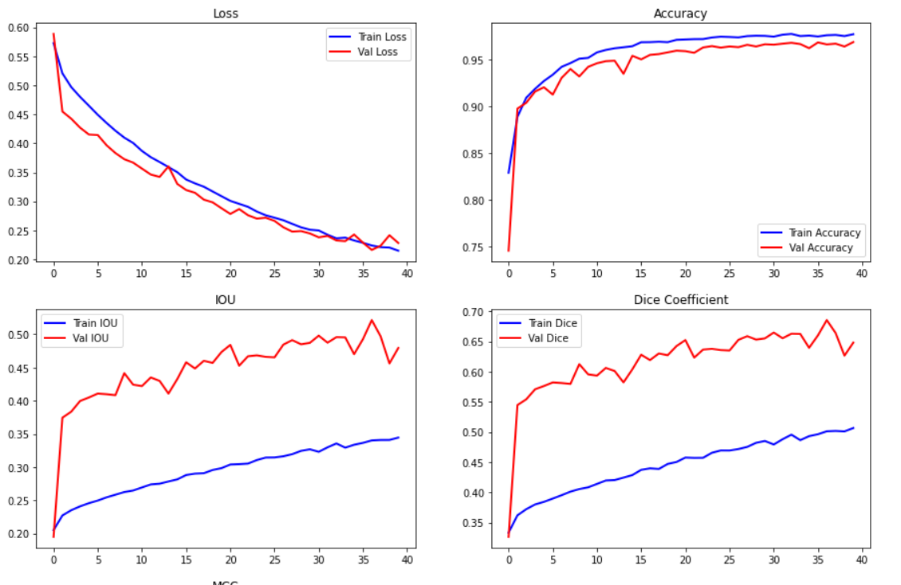

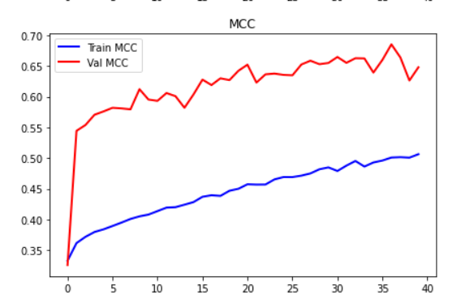

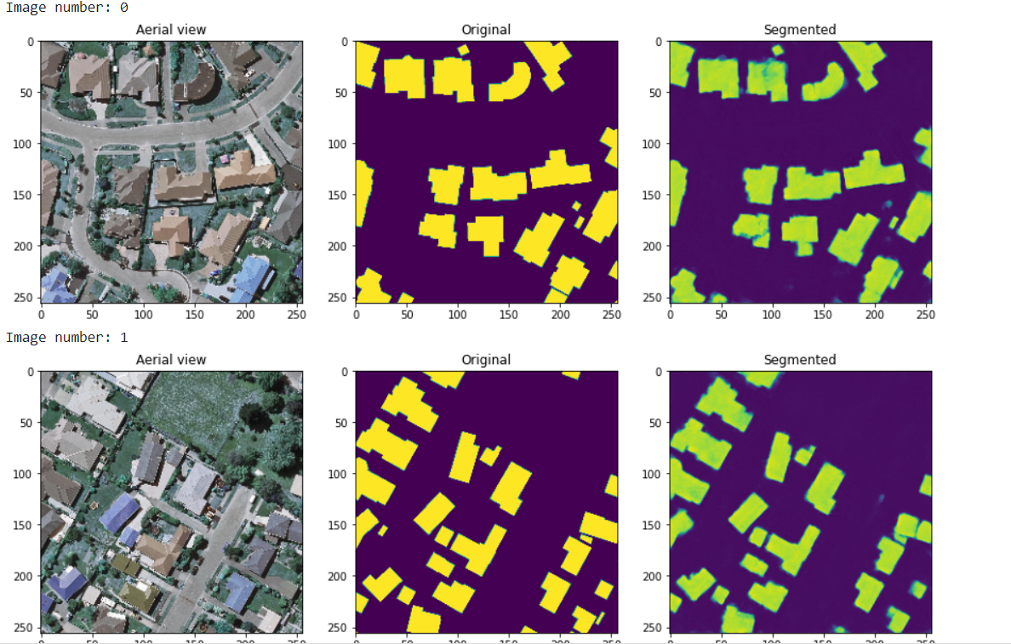

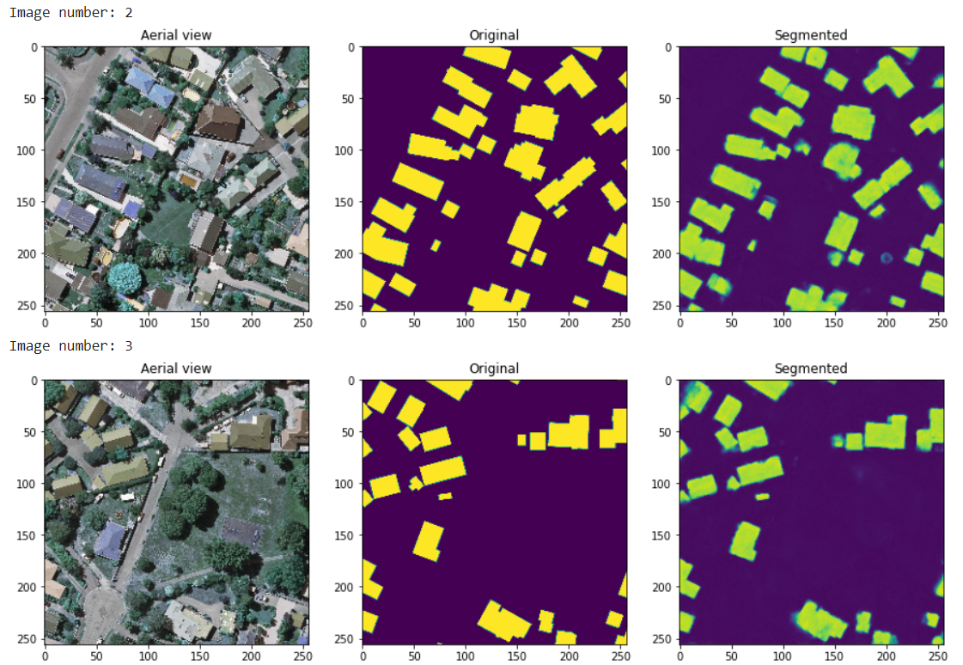

**Testing Data**

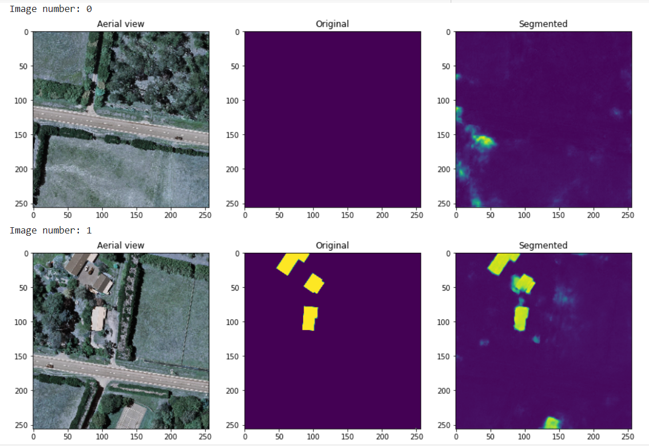

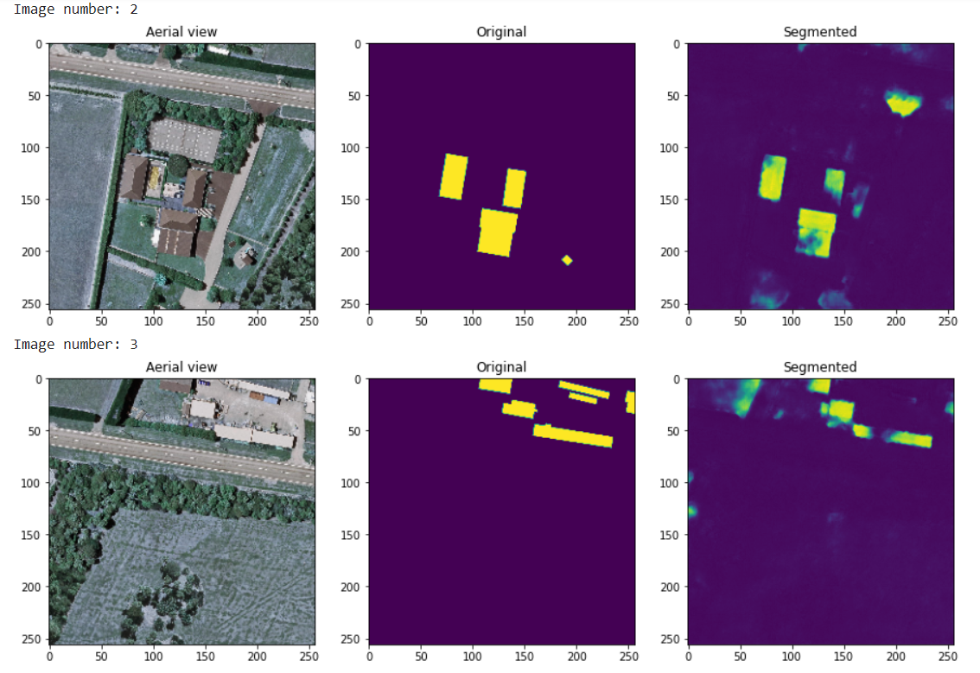

**Model Name:** multires-pro-1500images-bp-50epochs

**Architecture:** MultiRes U-Net

**Numpy or Image Generator:** Numpy

**Epochs:** 50 (256*256)

**Batch size:** 8

**Learning rate:** 0.0001

**No of images:** 1548

**Performance Metrics:** IOU, Dice Coefficient, MCC, Accuracy

**Colab or Kaggle:** Colab Pro

**Filename:** Revelation - Pro - MultiRes UNet

**Results:** IOU - 34.15, Dice Coefficient - 50.56, MCC - 1.21, Accuracy - 98.46, Loss - 0.2535

**Comments:** <https://github.com/nibtehaz/MultiResUNet/issues/16>. In this model, IOU formula is as previously used. But tried the new IOU formula given in the above link (rounding off) and IOU worked well for val and test image. BP filters are used. Same for dice coefficient.

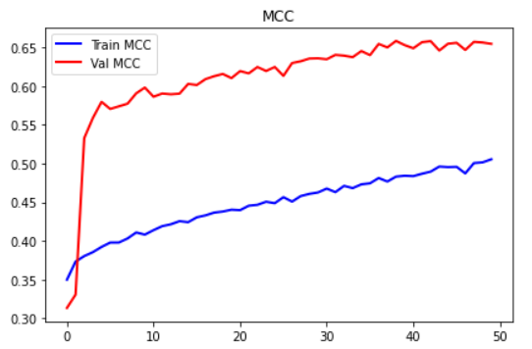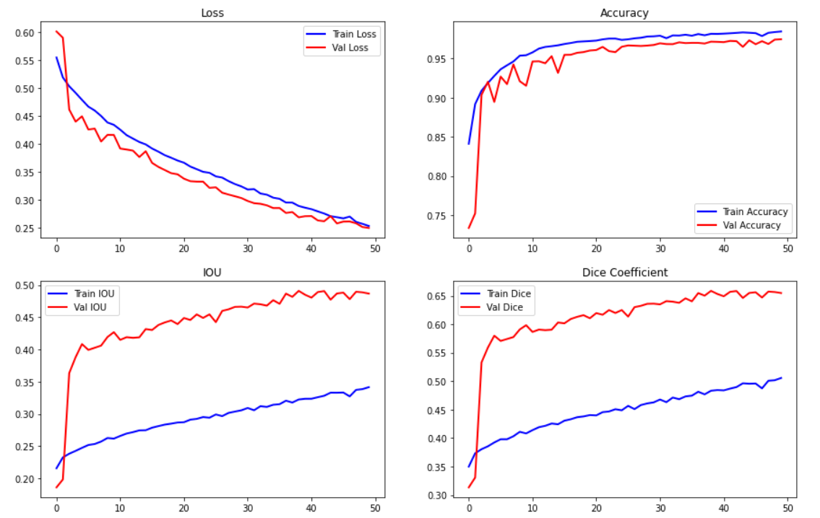

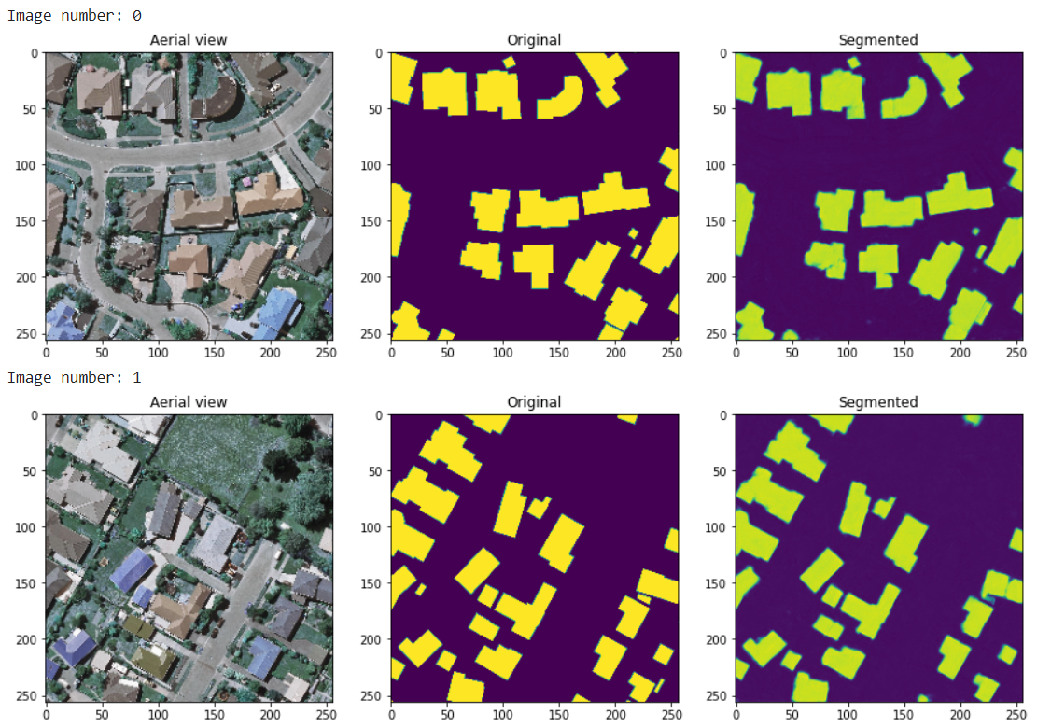

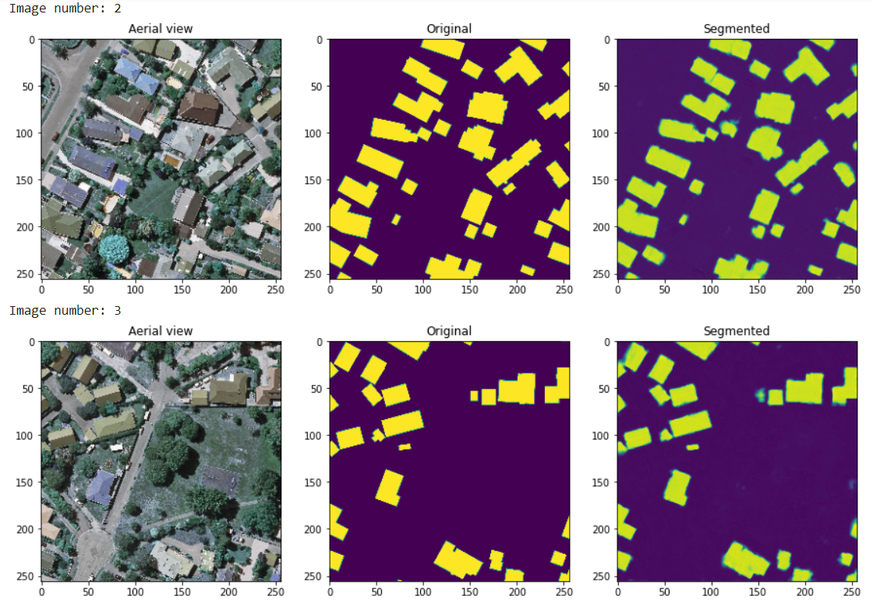

**Testing data**

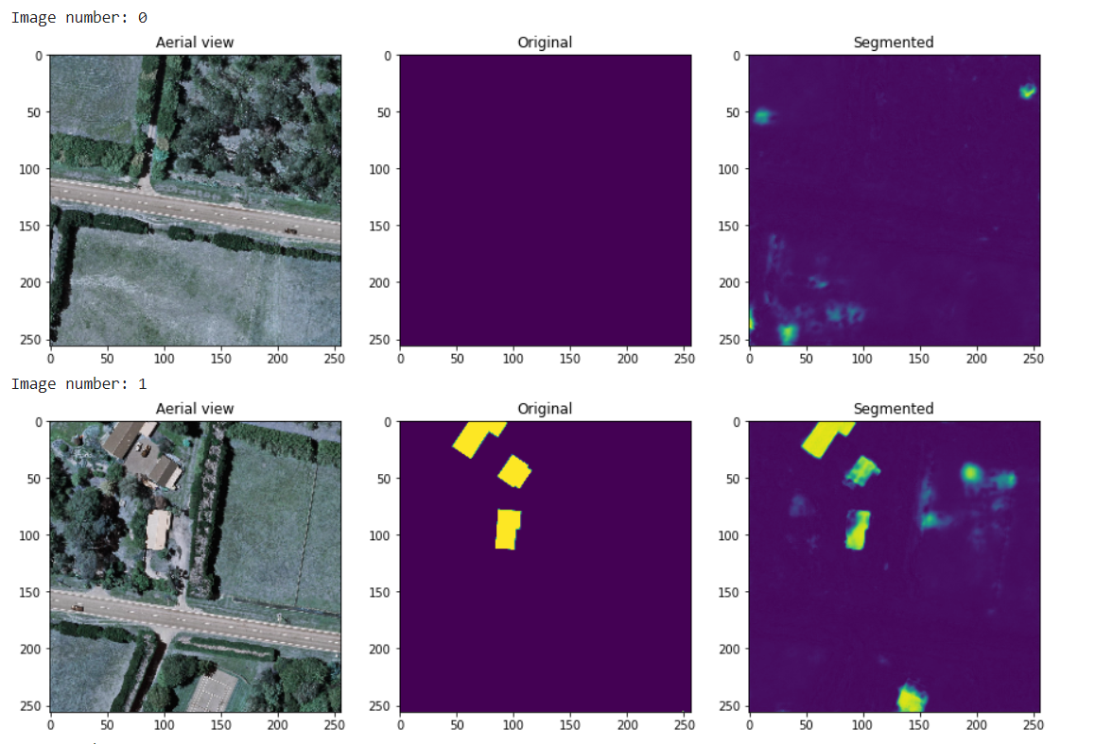

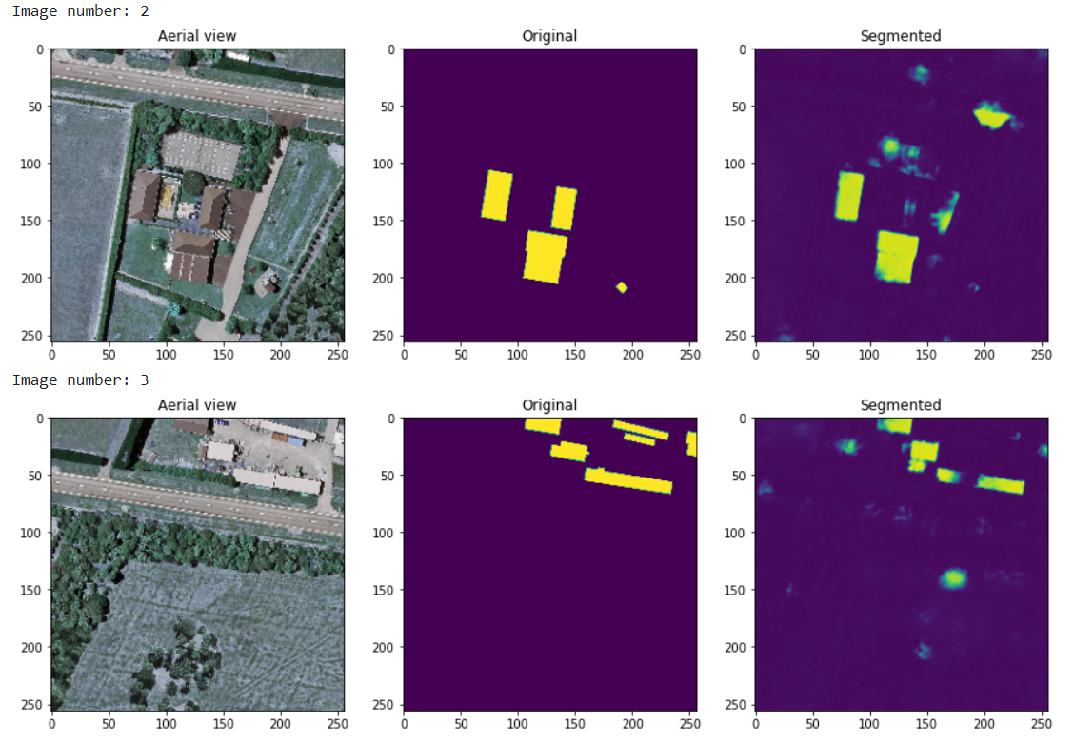

**Model Name:** multires-pro-allimages-100epochs

**Architecture:** MultiRes U-Net

**Numpy or Image Generator:** Numpy

**Epochs:** 100 (256*256)

**Batch size:** 8

**Learning rate:** 0.0001

**No of images:** 1548

**Performance Metrics:** IOU, Dice Coefficient, MCC, Accuracy

**Colab or Kaggle:** Colab Pro

**Filename:** Revelation - Pro - MultiRes UNet

**Results:** IOU - 38.84, Dice Coefficient - 55.86, MCC - 2.31, Accuracy - 98.54, Loss - 0.1713

**Comments:** Excellent results.

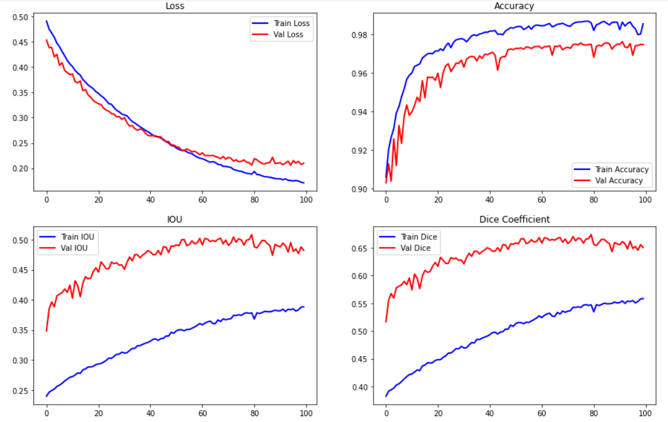

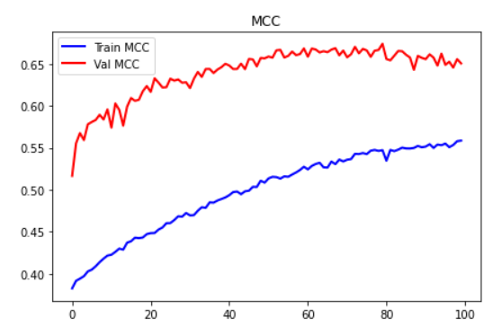

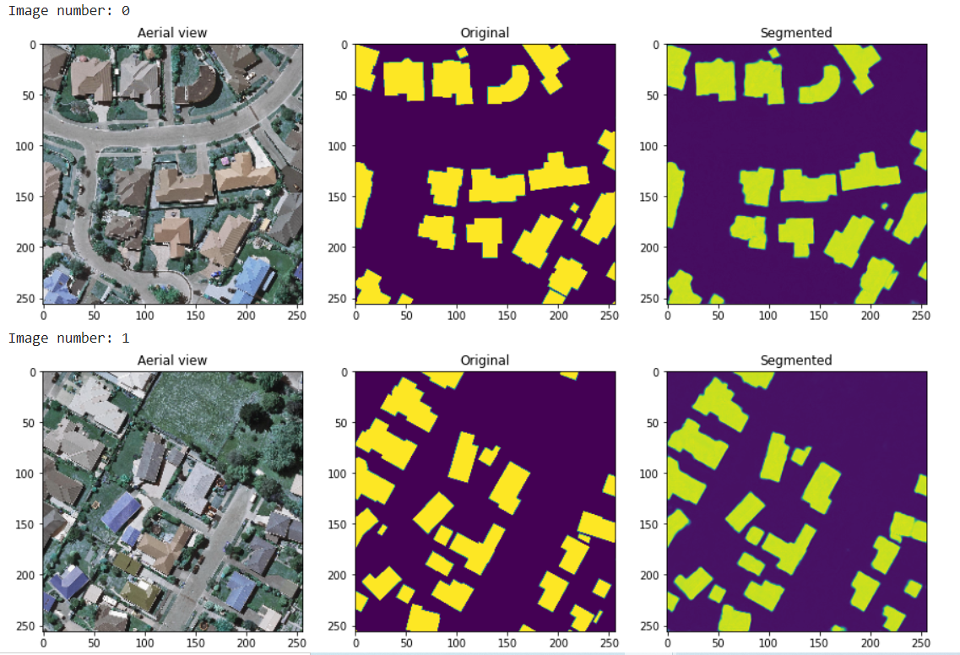

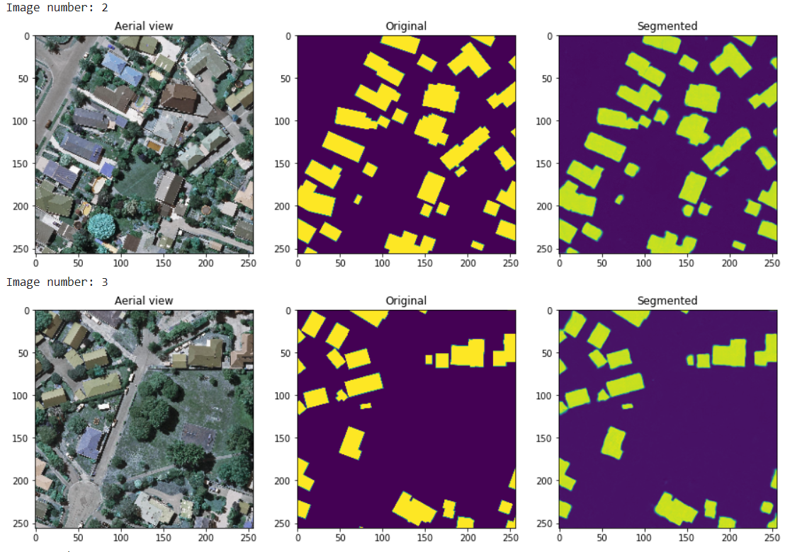

**Model Name:** multires-pro-1500images-bp-100epochs

**Architecture:** MultiRes U-Net

**Numpy or Image Generator:** Numpy

**Epochs:** 100 (256*256)

**Batch size:** 8

**Learning rate:** 0.0001

**No of images:** 1548

**Performance Metrics:** IOU, Dice Coefficient, MCC, Accuracy

**Colab or Kaggle:** Colab Pro

**Filename:** Final v1 MultiRes UNet

**Results:** IOU - 93.53, Dice Coefficient - 96.25, MCC - 95.87, Accuracy - 98.51, Loss - 0.1734

**Comments:** Base paper filters - final version 1 with changed formula.

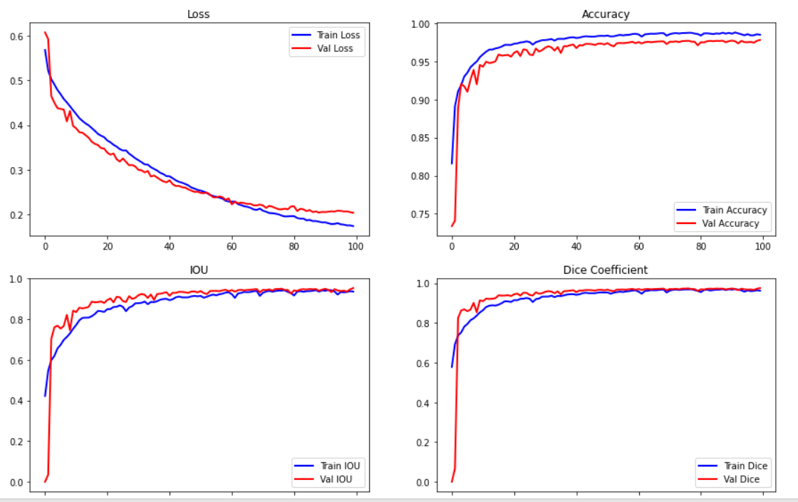

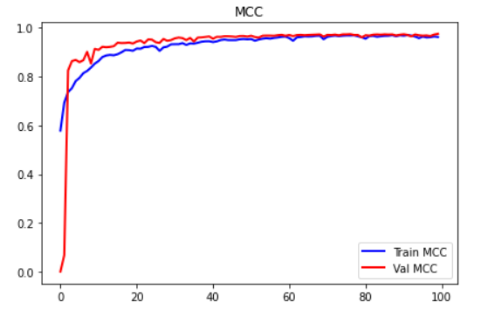

**Validation data**

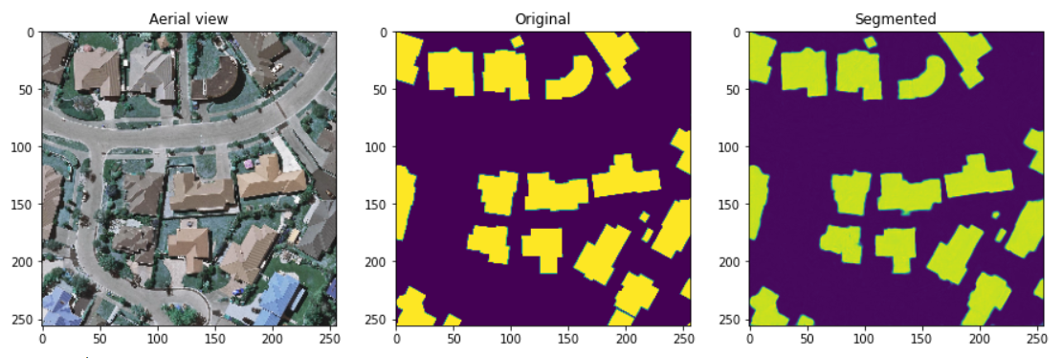

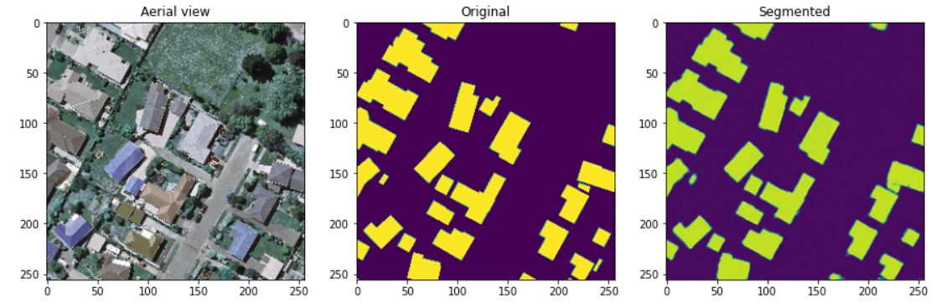

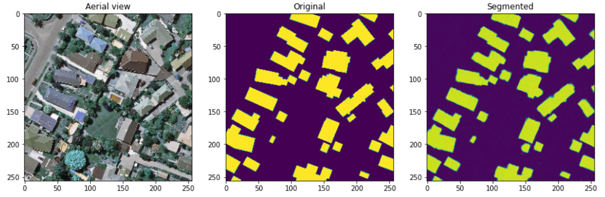

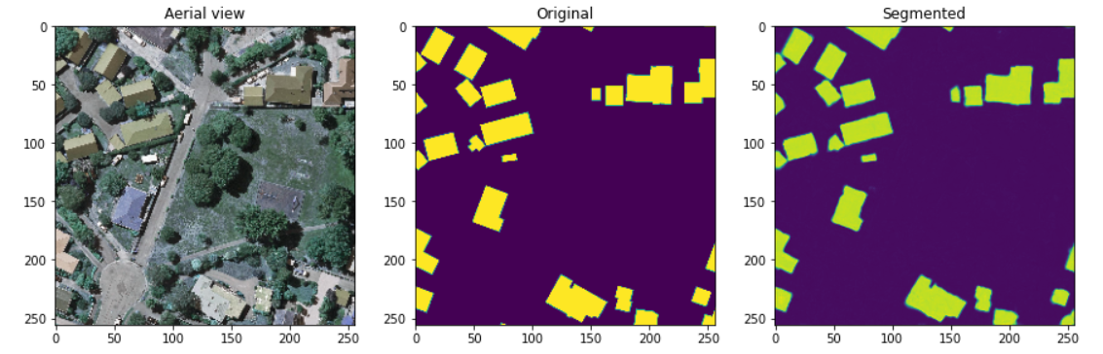

**Testing data**



